**Capstone Project – The Battle of Neighborhoods  
Rose Barzilai**

**Vegetarian restaurants in the biggest cities of the Netherlands**

**Introduction**You are visiting the Netherlands and you are vegetarian. You want to stay in a city where you have nice vegetarian places where you don’t need to search for a restaurant for hours. We are going to do an analysis that looks at the 5 biggest cities in the Netherlands and finds vegetarian restaurants. What is the best city for a tourist to go if he/she is vegetarian? The target group in this case is a vegetarian tourist.

**Data**We will connect to the Foursquare API to collect data about vegetarian restaurants in 5 big cities in the Netherlands: Amsterdam, Rotterdam, Breda, Utrecht and Den Haag. Here we will have the biggest change of getting a nice vegetarian dinner.

**Methodology**We would like to know which of the 5 Dutch cities has the highest vegetarian store density. We collect the data by using the Foursquare API and insert the ; vegetarian restaurant’ venue. The near query is used to get venues of the cities. We get a maximum of 100 venues per query. We repeated this for all the 5 cities. We save the names an coordinates and plot them on the map to check in which cities the vegetarian restaurants are close by.

We also would like to have a density indicator of vegetarian places in the different cities. Therefore, we calculate the centre coordinate of the venues to get the mean longitude and latitude values. We calculate the mean of the Euclidean distance from each venue tot the mean coordination.

**Results**Of we look at the visuals we see that all the five cities have multiple vegetarian dinner places, and probably more than we would see from this Foursquare data. Here some pictures of the geoplots with the restaurants per city:

**Amsterdam:**

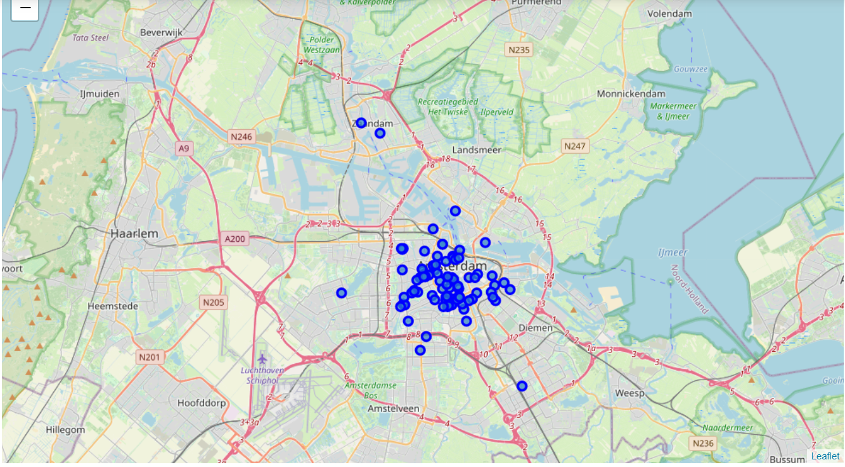

**Rotterdam:**

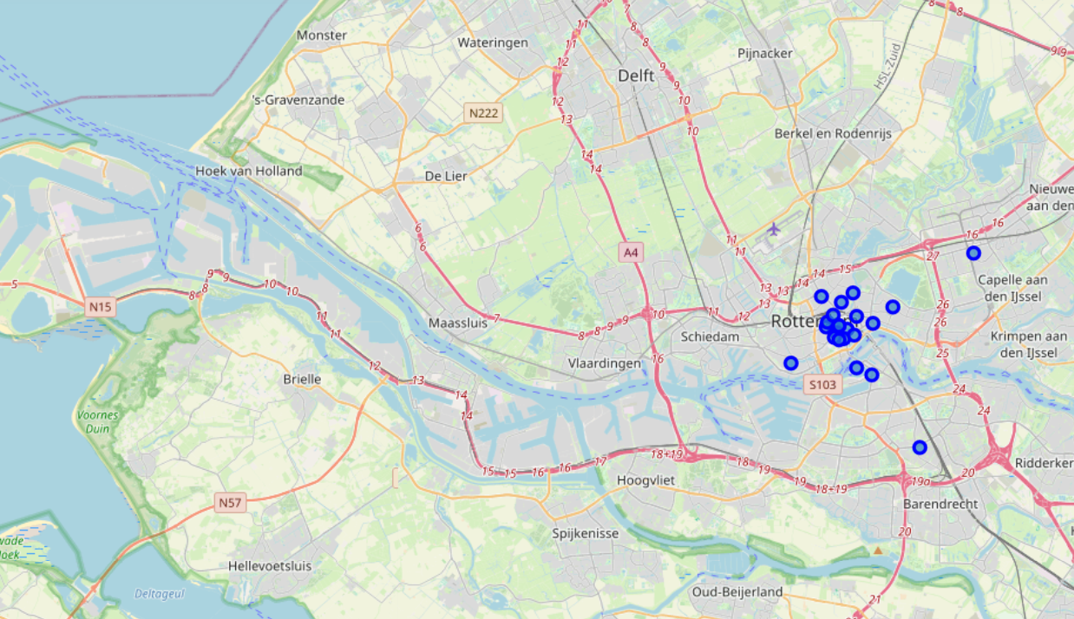

**Breda:**

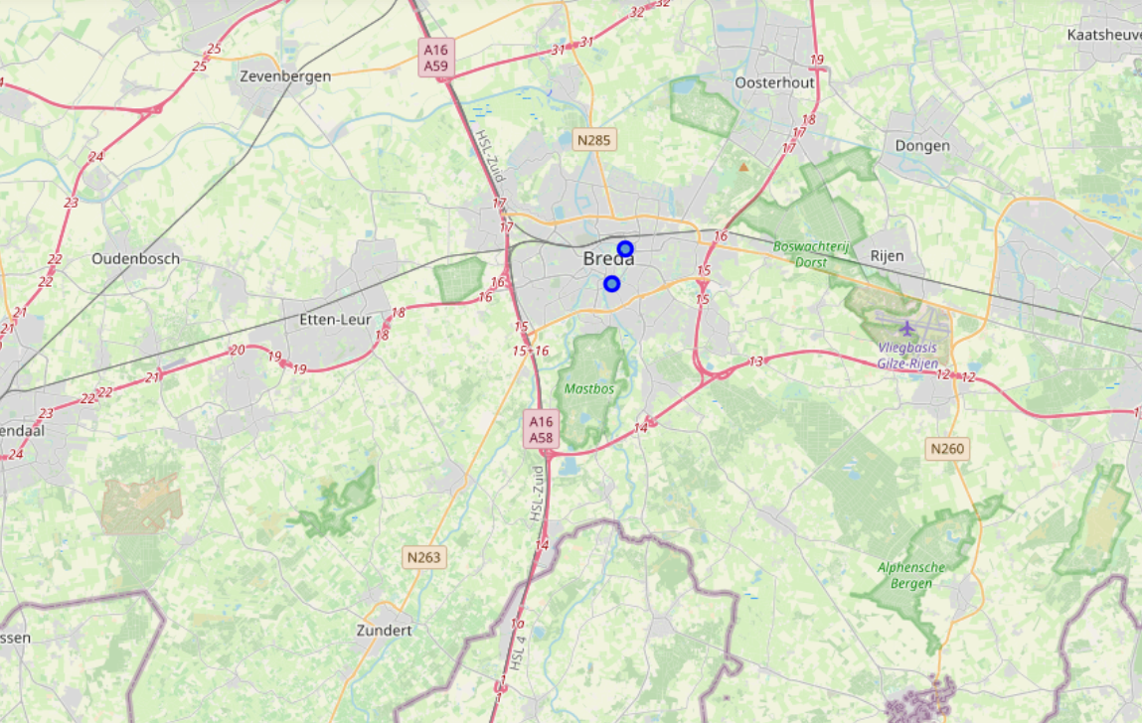

**Utrecht:**

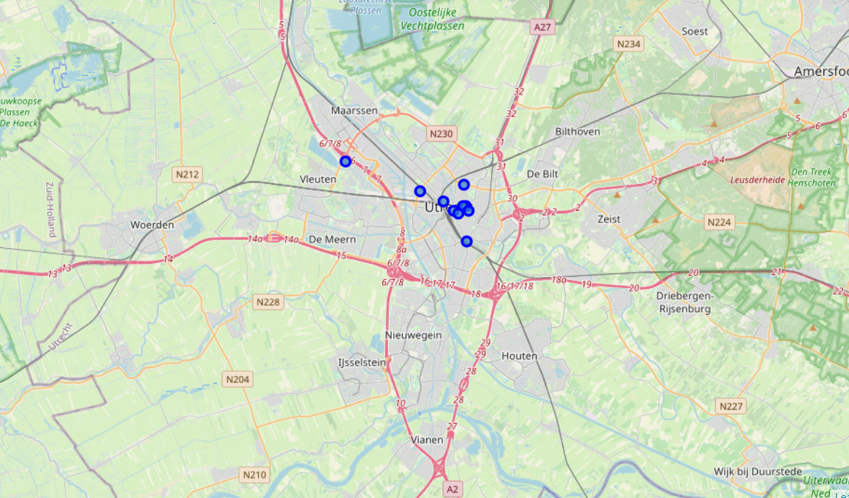

**Den Haag:**

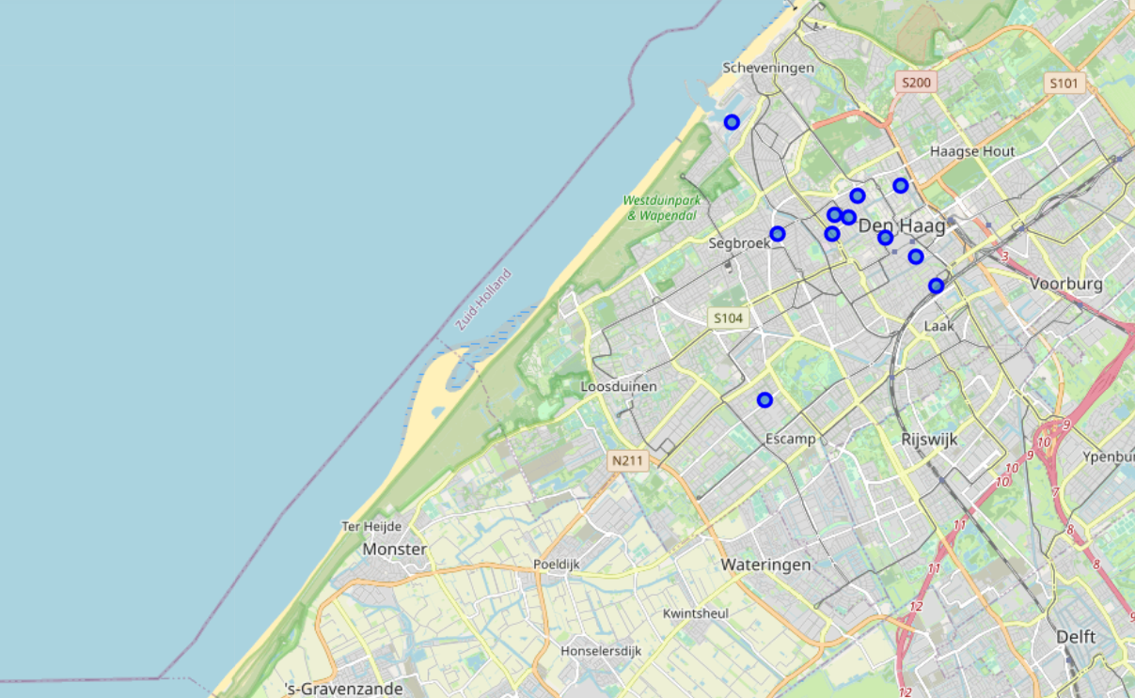

From these plots we see that Amsterdam and Rotterdam are the places to go when you are looking for vegetarian dinner! But let’s also take a look at the distance:

**Amsterdam:**MDMC: 0.0234  
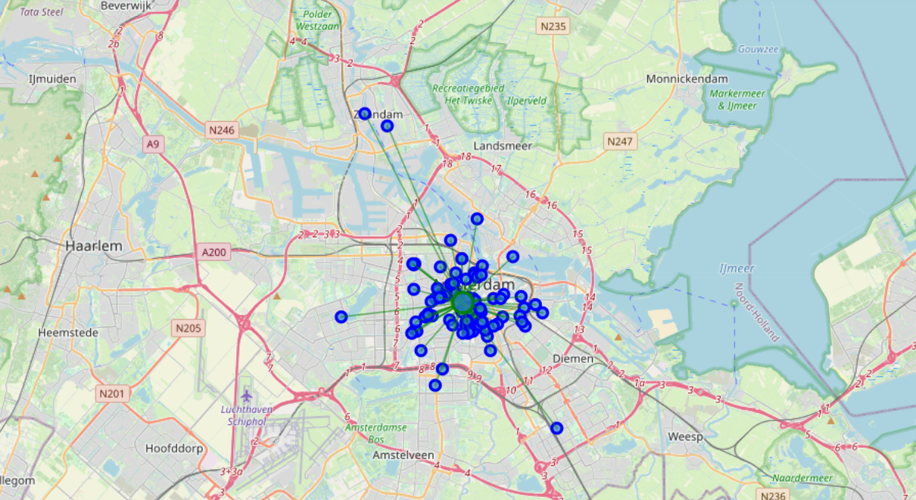

**Rotterdam:**MDMC: 0.0177

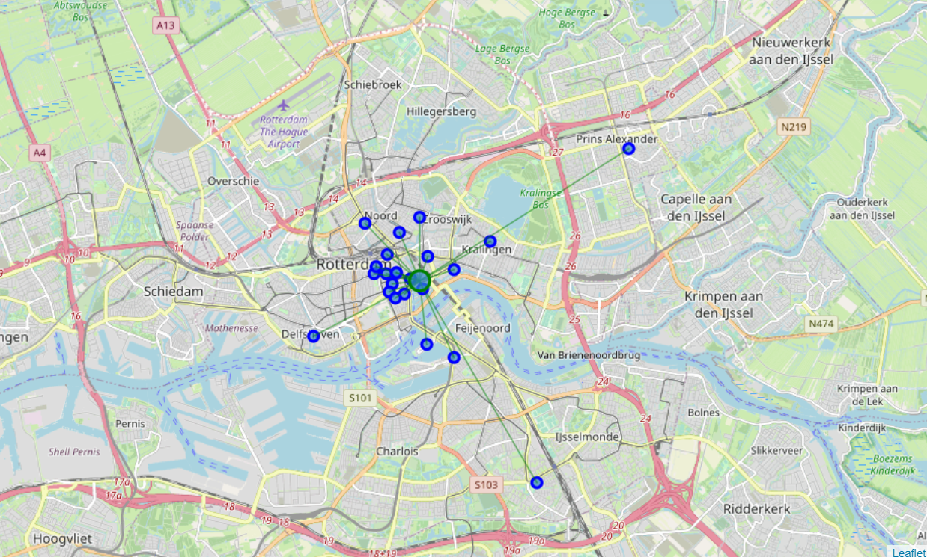

**Breda:**MDMC: 0.2075

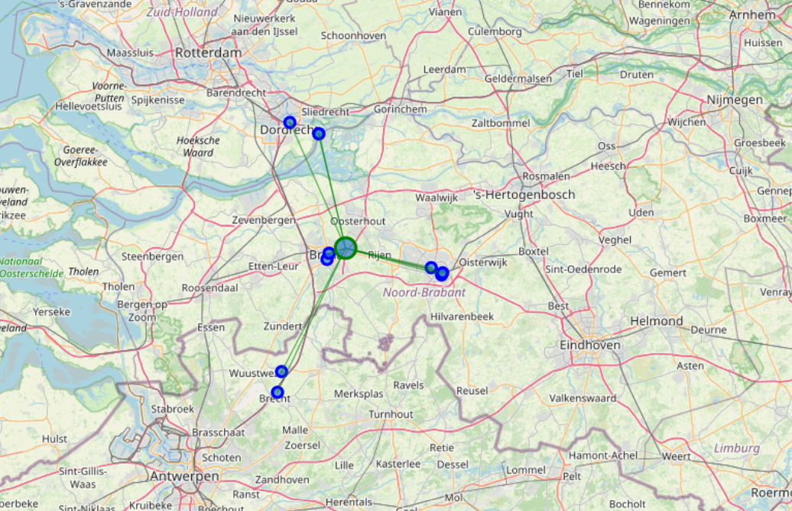

**Utrecht:**MDMC: 0.0200

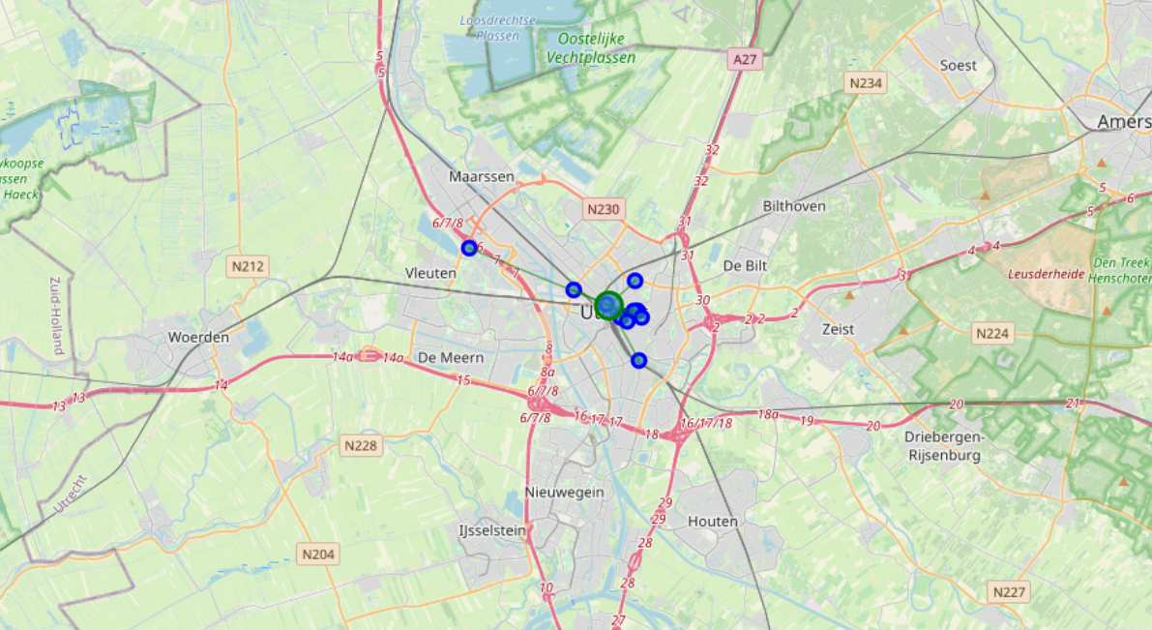

**Den Haag:**MDMC: 0.0165

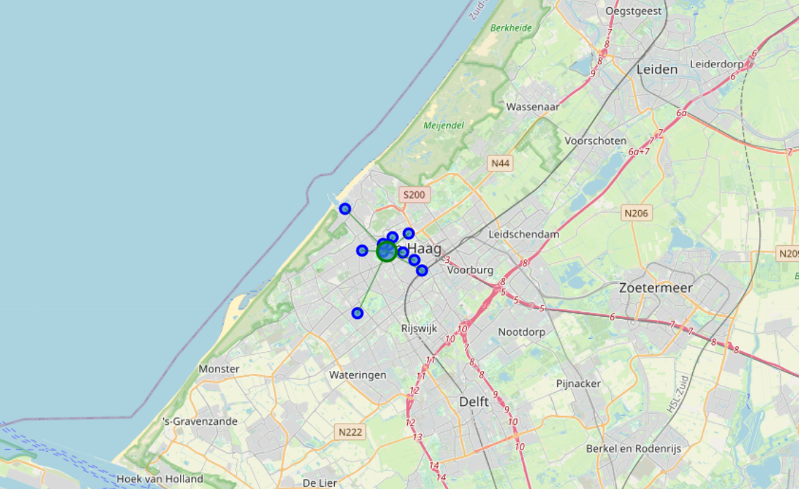

**Discussion**So the order is: Rotterdam, Den Haag, Utrecht, Amsterdam, Breda. If we look at Breda there are only 2 restaurant that are super close and the rest is very far away. This is probably not a good city to go when we want to have a choice in multiple vegetarian restaurants. The MDMC is skewed because the restaurants are located in other cities, but counted as Breda restaurants.

**Conclusion**So Rotterdam is the best city to go when you would like to have vegetarian dinner. The best idea for the tourist is to book a hotel close to the mean coordinate of the city. Because then he will have the most vegetarian restaurant close by!